24CSI024L – DATA STRUCTURE AND ALGORITHMS

Name : Hariharan B
Roll no: 25BAD030

Experiment no: 1A
Date: 17/07/2026

IMPLEMENTATION OF LIST USING ARRAY ADT

AIM:
To implement the List Abstract Data Type (ADT) using an array in C, and to perform operations such as insertion, deletion, searching, updating, and displaying elements.

Pseudo Code:
START
INITIALIZE n ← 0
REPEAT
DISPLAY MENU
1. Insert
2. Delete
3. Update
4. Display
5. Exit

INPUT choice
CASE choice OF
1:
Perform Insertion
2:
Perform Deletion
3:
Perform Updation
4:
Perform Display
5:
EXIT
DEFAULT:
PRINT "Invalid Choice"

ENDCASE
UNTIL choice = 5
STOP

CODE:
#include <stdio.h>
#define MAX 100
int arr[MAX];
int n = 0;
void insert()
{
int value;
printf("Enter value to insert: ");
scanf("%d", &value);
arr[n] = value;
n++;
printf("Element inserted successfully.\n");
}
void delete()
{
int pos, i;
printf("Enter position to delete: ");
scanf("%d", &pos);
if(pos < 1 || pos > n)
{
printf("Invalid position.\n");
return;
}
for(i = pos - 1; i < n - 1; i++)
{
arr[i] = arr[i + 1];
}
n--;
printf("Element deleted successfully.\n");
}
void update()
{
int pos, value;
printf("Enter position to update: ");
scanf("%d", &pos);
if(pos < 1 || pos > n)
{
printf("Invalid position.\n");
return;
}
printf("Enter new value: ");
scanf("%d", &value);
arr[pos - 1] = value;
printf("Element updated successfully.\n");
}
void display()
{
int i;
if(n == 0)
{
printf("List is empty.\n");
return;
}
printf("List Elements: ");
for(i = 0; i < n; i++)
{
printf("%d ", arr[i]);
}
printf("\n");
}
int main()
{
int choice;
do
{
printf("\n--- LIST ADT USING ARRAY ---\n");
printf("1. Insert\n");
printf("2. Delete\n");
printf("3. Update\n");
printf("4. Display\n");
printf("5. Exit\n");
printf("Enter your choice: ");
scanf("%d", &choice);
switch(choice)
{
case 1:
insert();
break;

case 2:
delete();
break;

case 3:
update();
break;

case 4:
display();
break;

case 5:
printf("Exiting...\n");
break;

default:
printf("Invalid choice.\n");
}
} while(choice != 5);
return 0;
}

OUTPUT:
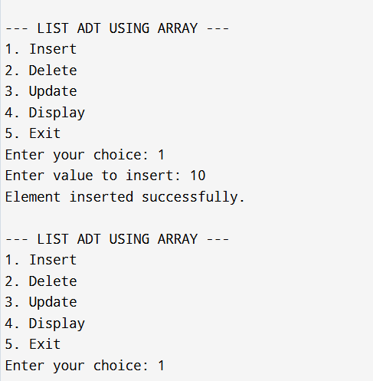
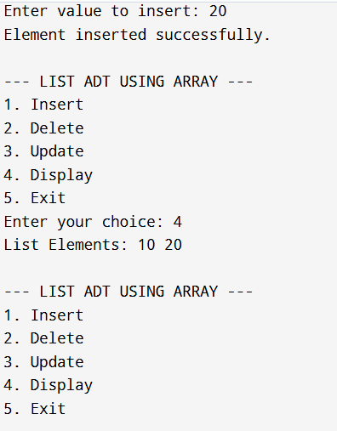
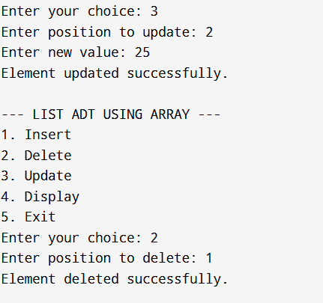
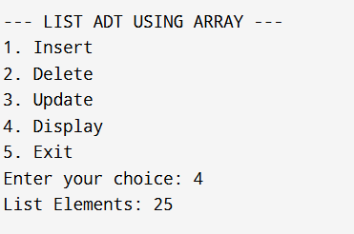

RESULT:

The List ADT was successfully implemented using an array in C. Operations such as insertion, deletion, searching, updating, and displaying were performed and verified to work correctly.

Experiment no: 1B
Date: 17/07/2026

LINEAR SEARCH USING AN ARRAY ADT

AIM:
To implement Linear Search operation on a List Abstract Data Type (ADT) using an array in C.

PSEUDO CODE:
START
Create a structure List
data[MAX]
size
Procedure INITIALIZE(List L)
Set L.size = 0
End Procedure
Procedure INSERT(List L, item)
If L.size = MAX
Print "List is Full"
Return
End If

L.data[L.size] = item
L.size = L.size + 1
End Procedure
Procedure DISPLAY(List L)
If L.size = 0
Print "List is Empty"
Return
End If

Print "List Elements:"
For i = 0 to L.size - 1
Print L.data[i]
End For
End Procedure
Function LINEARSEARCH(List L, key)
For i = 0 to L.size - 1
If L.data[i] = key
Return i
End If
End For

Return -1
End Function
MAIN PROGRAM
Create List L
Call INITIALIZE(L)

Read n

For i = 0 to n - 1
Read item
Call INSERT(L, item)
End For

Call DISPLAY(L)

Read key

position = LINEARSEARCH(L, key)

If position ≠ -1
Print "Element found at index", position
Else
Print "Element not found"
End If

STOP

Program:
#include <stdio.h>
#define MAX 100
typedef struct
{
int data[MAX];
int size;
} List;
void initialize(List *L)
{
L->size = 0;
}
void insert(List *L, int item)
{
if (L->size == MAX)
{
printf("List is Full!\n");
return;
}

L->data[L->size] = item;
L->size++;
}
void display(List *L)
{
if (L->size == 0)
{
printf("List is Empty!\n");
return;
}

printf("List Elements: ");
for (int i = 0; i < L->size; i++)
{
printf("%d ", L->data[i]);
}
printf("\n");
}
int linearSearch(List *L, int key)
{
for (int i = 0; i < L->size; i++)
{
if (L->data[i] == key)
{
return i;
}
}
return -1;
}
int main()
{
List L;
initialize(&L);

int n, item, key;

printf("Enter number of elements: ");
scanf("%d", &n);

printf("Enter elements:\n");
for (int i = 0; i < n; i++)
{
scanf("%d", &item);
insert(&L, item);
}

display(&L);

printf("Enter element to search: ");
scanf("%d", &key);

int pos = linearSearch(&L, key);

if (pos != -1)
printf("Element found at index %d\n", pos);
else
printf("Element not found.\n");

return 0;
}

OUTPUT:
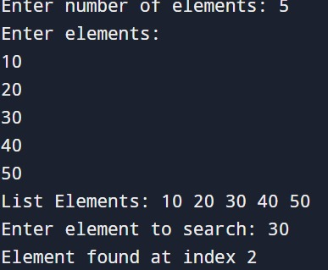

RESULT:

The List ADT using Linear Search was implemented successfully. The program correctly searched for the given element and displayed the appropriate result.

Experiment no : 1C
Date: 17/07/2026

BINARY SEARCH USING AN ARRAY IN ADT

AIM:
To implement Binary Search using List ADT (Array) in C.
PSEUDO CODE:
START
Create a structure List
data[MAX]
size
Procedure INITIALIZE(List L)
L.size ← 0
End Procedure
Procedure INSERT(List L, item)
If L.size = MAX
Print "List is Full"
Return
End If

L.data[L.size] ← item
L.size ← L.size + 1
End Procedure
Procedure DISPLAY(List L)
Print "List Elements:"
For i ← 0 to L.size - 1
Print L.data[i]
End For
End Procedure
Function BINARYSEARCH(List L, key)
low ← 0
high ← L.size - 1

While low ≤ high
mid ← (low + high) / 2

If L.data[mid] = key
Return mid
Else If L.data[mid] < key
low ← mid + 1
Else
high ← mid - 1
End If
End While

Return -1
End Function
MAIN
Create List L
Call INITIALIZE(L)

Read n
For i ← 0 to n - 1
Read item
Call INSERT(L, item)
End For
Call DISPLAY(L)
Read key
position ← BINARYSEARCH(L, key)
If position ≠ -1
Print "Element found at index", position
Else
Print "Element not found"
End If
STOP
Program:
#include <stdio.h>
#define MAX 100
typedef struct
{
int data[MAX];
int size;
} List;
void initialize(List *L)
{
L->size = 0;
}
void insert(List *L, int item)
{
if (L->size == MAX)
{
printf("List is Full!\n");
return;
}

L->data[L->size] = item;
L->size++;
}
void display(List *L)
{
printf("List Elements: ");
for (int i = 0; i < L->size; i++)
{
printf("%d ", L->data[i]);
}
printf("\n");
}
int binarySearch(List *L, int key)
{
int low = 0;
int high = L->size - 1;

while (low <= high)
{
int mid = (low + high) / 2;

if (L->data[mid] == key)
return mid;
else if (L->data[mid] < key)
low = mid + 1;
else
high = mid - 1;
}

return -1;
}
int main()
{
List L;
initialize(&L);

int n, item, key;

printf("Enter number of elements: ");
scanf("%d", &n);

printf("Enter %d elements in sorted order:\n", n);
for (int i = 0; i < n; i++)
{
scanf("%d", &item);
insert(&L, item);
}

display(&L);

printf("Enter element to search: ");
scanf("%d", &key);

int pos = binarySearch(&L, key);

if (pos != -1)
printf("Element found at index %d\n", pos);
else
printf("Element not found.\n");

return 0;
}

OUTPUT:
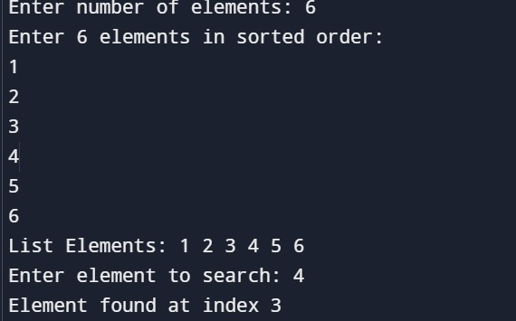

RESULT:
The Binary Search using List ADT was implemented successfully. The program correctly searched for the given element and displayed the appropriate result.

